COURSEWORK 2 - DOCUMENTATION

WEB DESIGN AND DEVELOPMENT

                                                                                                CIS1110

Jamie Ashcroft

23977540

Tutor – Dave Walsh

Word Count - 1135

Index

Solution - 3 - 5

Thought Process 5 - 6

Bibliography - 7

***Testing Documentation***

***Introduction***

Throughout this report I will present my testing for the responsive website that I have built as part of coursework two for web design and development. I aim to provide a well-structured report detailing all the testing taken place, this includes the following; browser compatibility, validation testing, user testing, any issues or bugs found throughout and more. Each section of testing will be outlined in the contents for easy access and any images of testing will be clear to understand and well annotated.

***Browser Compatibility***

***Validation Testing***

***Brief Overview***

Throughout this section you will find the generic testing of the website, from basic layout, detailed design and functionality. These will all be tested against the specified requirements, in this case, how well we replicated the website as well as specific design requirements given to me. The testing here will be most extensive as I have included all the steps taken to build the website up from scratch, wherever I run into a problem I will discuss briefly in this section and in detail under bugs and issues testing/resolving.

***Index Page Layout***

(Based on indexpage.png)

Wrapper

Logo

Navigation bar

Index.html

Products.html

Header

Slogan

Main Content

Popular Products

Company News

Reader Poll

Footer(s)

I coded the website bit by bit based on the layout and tested the outcome for the placement of each element within a section, at this point I was only placing the elements needed, separating them using mainly div tags to show sections of the page. Below I will explain this in detail for each section.

*Initial Head*

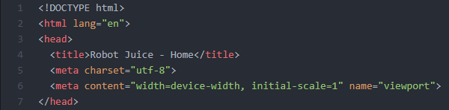This is the initial code used for the head element, the first thing coded to start off the website, I expand on this element throughout. Essentially, here I am just declaring a few basics for the website in this case it is the webpage title, and some meta information. Additionally, I will add my styles, scripts and more to this tag as I develop the web pages.

*Wrapper*

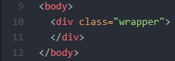To begin with, I instantly created a wrapper class, within the body, as a div. This is where I will place a huge chunk of the elements within the page as it will allow me to style them all at once, this will mainly be for text and placement within the grid.

*Logo*

*(Testing whether the logo elements appear on the webpage)*

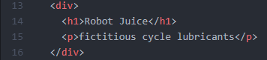As specified in the design documentation for the logo, it is created using text elements within HTML and is not an image. Therefore, I have split the logo into two parts, a H1 tag and a P tag. Each section of the webpage is shown with the use of div tags, you’ll notice throughout that I have enclosed them all in div tags but haven’t included unique identifiers yet as that will come later when I get around to styling the elements.

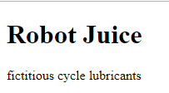This is what appears when I load the index.html page into my web browser, without any styling it is just presented as the default elements. This test was successful and gave the expected outcome.

*Navigation Bar*

*(Testing whether the nav bar code displays on the webpage in an unordered list and as clickable links)*

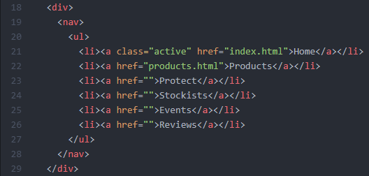This website only actually requires two pages to be functioning, but there is a total of 6 nav options within the nav bar which still must be coded for show. This is the basic code I have written to hopefully display the navbar in a basic unordered list with each one a clickable element. Highlighted in the red circle are the elements we are testing.

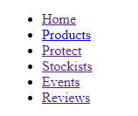This is how the code was displayed within the web browser, as you can see we have included all of the required nav links and they have been placed, successfully, into an unordered list. Furthermore, you can see from the styling that they’re all clickable links, however, only the home and products links have navigation options the rest will just remain on the current loaded page when clicked. This test was successful.

*Header – Error(s)*

*(Testing whether the header is displayed on the webpage)*

https://i.gyazo.com/825b47b6b6beb4fd057146333a67a10b.pngThe simplest of tests for the index HTML is the website header, the image was provided for me and all I had to do was place it onto the webpage, this was the initial code used and this was the first test result.

https://i.gyazo.com/ec5ee6e83f91bae70b3869f62765a631.pnghttps://i.gyazo.com/dd43ffaebd4ca603a9456a93977d894e.pngAs you can see the image is not being displayed on the page for some reason, this is when I remembered that I have placed all my images inside a folder named ‘images’. Therefore, I have to tell my code that it is inside that folder otherwise it can’t find the image, at least we can see from this test that my ‘alt’ tag is working correctly.

Here you can see highlighted the simple change we made to the code by adding in the ‘images\’ part into the code which tells the page that the image is inside another folder within my project.

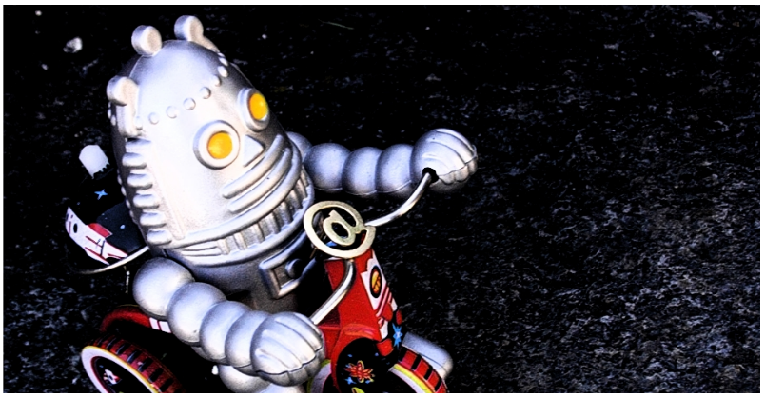With the updated code in place this is how the image looked when the web page was refreshed. This test was now successful with all errors fixed.

*Slogan*

*(Testing the basic display of the ‘Slogan’ section of the code)*

This is the code for the slogan, it’s very basic and it is a <p> tag inside a div. This should simply display on the page under the header as a paragraph as shown in the code.

https://i.gyazo.com/d6cccbe0f35910fbeaa885c3d6d9a98c.pngAs expected, the code is displayed correctly with no errors as of now. This is simply the HTML code and CSS testing will come later.

*Main Content – Section 1*

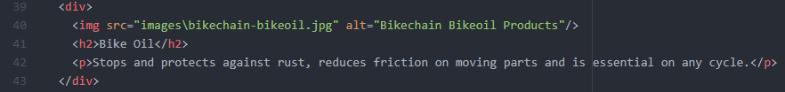*(Testing the HTML code is being displayed correctly and in the right order)*

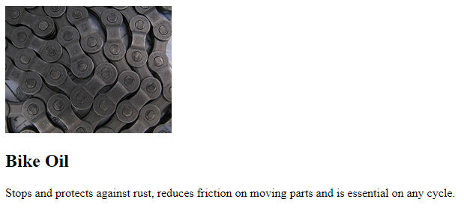This section of the website is split into four separate div tags and they are all the same code just with different images and text being displayed which is why I will just show you one of them as it is duplicate code. As you can see, I have displayed multiple elements within this div tag, and image, a header and a paragraph. I expect these three elements to be displayed on the webpage in order of code below each other.

The code has displayed as expected and with no errors. This is just the HTML layout for this section and it is repeated 3 more times with the same result.

*Main Content – Section 2*

*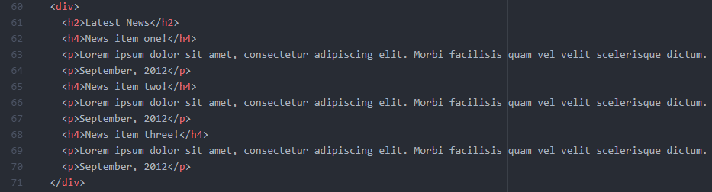(Testing the HTML code is being displayed correctly and in the right order)*

Once again, this is a simple test for displaying the HTML code in the right order. There are 3 sets of code within this div which are duplicated and renamed and then we have the main header at the top which is the title for this section ‘Latest News’. I expect with this code that it simply displays the elements in order on the website, there shouldn’t be any issues within this code.

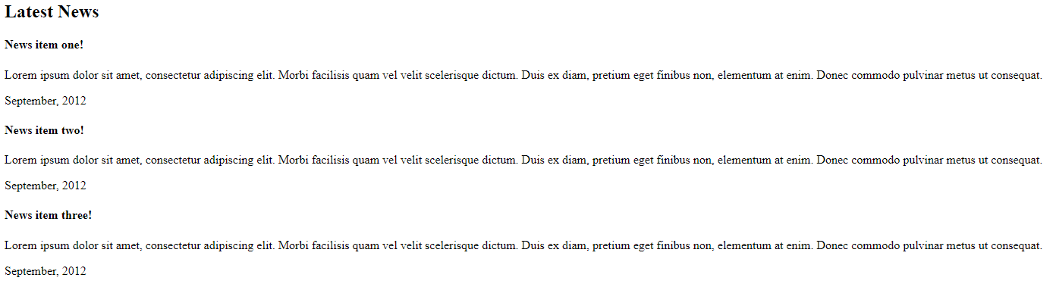Once again, this test went as expected. All the elements are being displayed in the right order and have all displayed correctly, no errors recorded for this test.

*Main Content – Section 3*

*(Testing basic form elements and the placement of HTML)*

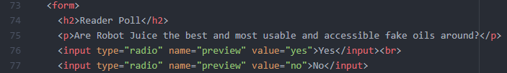This is the first section of the code I tested and it includes the placement of a header, paragraph and two radio buttons which I have placed inside a ‘<form>’ tag. As you can see both the buttons have been placed using basic HTML involving the creation of radio input buttons. I have also added in a break tag which displays the second tag below the first which is how it is supposed to be displayed. This test should allow me to click each of the radio buttons and nothing more as I haven’t coded the buttons any further.

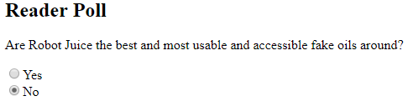As expected, this test was successful. The basic HTML header and paragraph tags have displayed correctly and the two radio buttons have been displayed and both of them are clickable radio buttons. No errors were recorded when testing this section of the webpage.

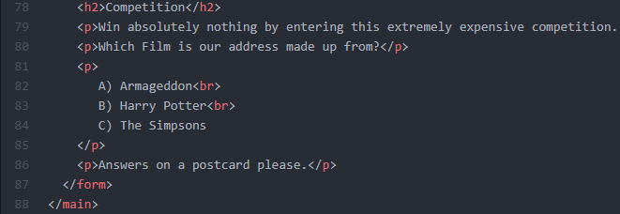This was the second section of this code which was simply to test the placement of HTML elements to complete the rest of the form tag. Also important to note this is the end of my ‘main’ tag as this is all the main content of the page and only the footers are left which are separate from this content. Once again, I added break tags at the end of the first and second ‘option’ within the second to last <p> tag to make sure they displayed on individual lines rather than all on the same.

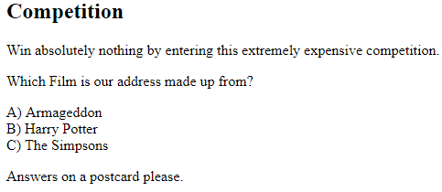As expected, this test was successful and all the elements where displayed in the right order and correctly. The break tags worked correctly too displaying each option on a separate line while being in the same element.

First footer – Section 1

(Testing element placement on the webpage for first section of the footer)

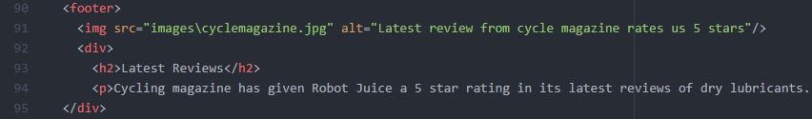The first footer is split into three different sections, the first being the image of the magazine, the second a simple header and paragraph placement and the third is a links section. I have split them into two different showings to make sure I show everything properly. This test is for the image and elements, within my div, webpage placement.

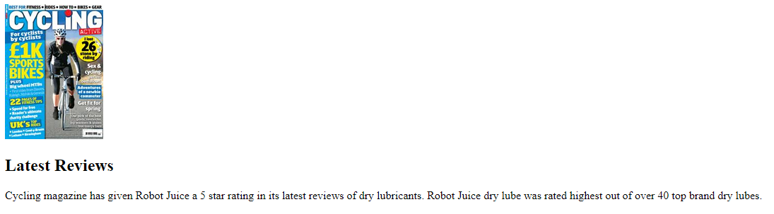This test was successful and the elements all displayed as I expected with no errors.

*First Footer – Section 2*

*(Testing list placement as well as navigational links are clickable)*

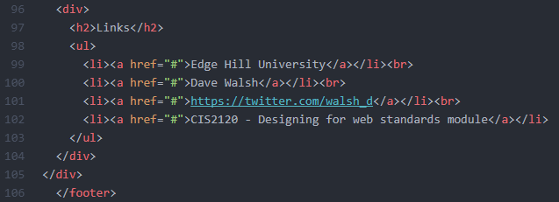Here I am simply testing the placement of the list and whether or not the links within the list are clickable. At the moment, they shouldn’t take us anywhere as they don’t have an actual reference to link to and so it should remain on the index page when pressed.

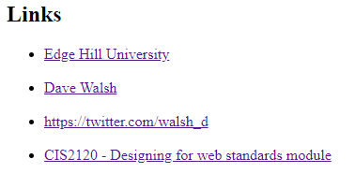As expected, this test was successful. The list has worked as intended and all the links within are clickable ones which don’t currently send us anywhere. This is the end of the first footer as I have split the footer into two parts as shown to us in the example work.

*Second Footer – Section 1 – Reference*

*(Testing element placement and the fraction entity found through research)*

<https://www.w3schools.com/charsets/ref_html_entities_4.asp>

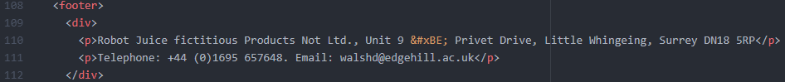

Here I am testing the placement of the basic HTML elements and, as highlighted in the image above, I am testing the HTML entity that I have included to create the ¾ effect. I didn’t know how to do this on my own so I turned to W3 schools to find the answer, link provided as reference.

https://i.gyazo.com/cc0cd887beed7b8711d799de8b65105a.png

As you can see, the HTML elements are all displaying correctly and the HTML entity I included is also displaying as intended as the fraction ¾ which is displayed using the code “&#xBE”.

*Second Footer – Section 2*

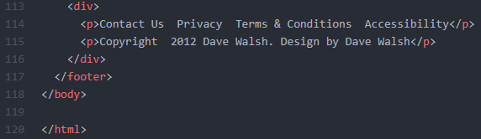*(Testing element placement on the webpage)*

Here is the code I am testing, once again very basic element placement. You can also see how this is the end of the file as we have closed of the body and html tags. I expect the elements to be displayed on the webpage below the previous content of the second footer.

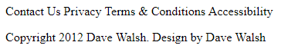Here is the result, as expected the elements are being displayed correctly with no errors.

***CSS***

The next step in testing is the CSS which I will implement to properly style my HTML pages, I decided to start the styling now before making the products HTML page because, for the majority, it will use the same styling and CSS with obvious changes for main content. The testing for the CSS will be far more extensive than the HTML coding which is why I will table some of my tests when I am continuously making changes and show images when needed.

First, I had to create and link my stylesheet with the HTML page that I have coded, to do this we add the following line of code *“<link href="styles\styles.css" rel="stylesheet" type="text/css">”.* To make sure we link it to the right place I must name the ‘href’ correctly, I have placed the file into a folder called styles which is why it is ‘styles\styles.css. This will now update the HTML when I make changes in the CSS file.

*Grid Styling*

First, I decided to code the basic principals of the CSS grid which I was tasked with using in order to get the shape of the webpage before styling any elements. To do this I made a separate file in my styles folder called grid.css and then linked it into my HTML page as shown above with the other stylesheet.

*Wrapper Grid*

|  |  |  |  |
| --- | --- | --- | --- |
| ***Test*** | ***Expected O/C*** | ***Actual O/C*** | ***Errors*** |
| Changing display to grid format. | Nothing to change as no parameters added for grid | Expected outcome achieved, no changes to HTML | n/a |
| Define grid columns to value of 4 across webpage | Little to no change, some elements may shift on the page because they’re outside the wrapper | Footer element moved to the top of the page alongside the logo, I can only assume because it’s outside the wrap | Footer, only temporary |
| Adding a max width of 940px, banner image width | Everything should wrap within that 940px max width set. Footer should go back to the bottom of the page | Everything but the first footer is wrapped within that max width, unknown why the footer is still at the top. | Footer is out of place, unsure why |
| Adding a margin with the value auto | All the elements on the page should shift to the centre of the page except the footers | Expected outcome achieved, first footer still out of place but I think that is because it is outside the grid | n/a |
| After wrap for grid columns & temp border | Make it so the default columns elements span on each browser is the same. Also small black border to appear for temp use to highlight divs. | Expected outcome achieved, grid will now span 4 no matter the browser the webpage is opened in. (This was pre-cautionary) Black border also appeared how intended. | n/a |

Errors Found (1)

The error I came across was the first footer appearing alongside the logo at the top of the webpage. At first, I thought this was because it was outside the wrapper, but after setting the grid span to 4 I realised the footer joined the grid and in the correct place. Then I decided to look at the HTML, which is when I found out I had misplaced the closing div tag for the wrapper and for some reason placed the footer within the wrapper which was causing it to be in the wrong position on the page.

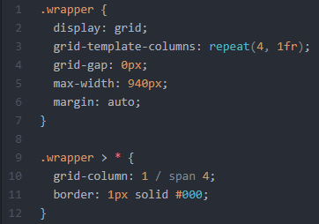

This was all the code used for testing the wrapper for the grid. With this I was able to setup the grid with 4 columns and centralise the elements to a max width of 940px. This max width was important as it’s the width of the banner image, on the image we were given nothing exceeds the width of the banner which is why I decided on this max-width.

*Element Styling*

Now that I have the basic grid setup and all the elements where I want them, I then turned to the styling of the elements themselves and started from the top to the bottom. To begin with I added two lines of CSS into the HTML document itself just to change the font and background colour, this can be seen in the image below.

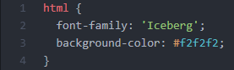The reason I set the font to ‘Iceberg’ is because the majority of the page uses this font, this in turn reduces the code as it will only change when coded in an element. Also, the background colour is just a light grey.

*Logo Styling*

|  |  |  |  |
| --- | --- | --- | --- |
| ***Test*** | ***Expected O/C*** | ***Actual O/C*** | ***Errors*** |
| Testing the classes implemented | The colour of the text that is the logo should change to red/black. | Expected outcome achieved, the classes are working. | n/a |
| Adding the external font ‘Damion’ | Font for both classes should change to ‘Damion’ | Expected outcome achieved, logo font updated to ‘Damion’ | n/a |
| Updating font size to 62px | Font size for the logo should increase in size to 62px | Expected outcome achieved, logos font size was updated to 62px | n/a |
| Adding margins for the logo | Added letter spacing of 3px to increase margin between each letter and added top margin to increase spacing from top of the webpage to 21px. | Expected outcome achieved, logos margins were implemented as intended. Possibly affected by the border but will be fine when border is removed | n/a |
| Changing font style and size of the p tag | Font changes to Ariel and font size increased to 13px | Expected outcome achieved, changes to the size and style applied to the p tag | n/a |
| Colour change of p tag | Colour updated to a grey colour slightly darker than BG colour | Expected outcome achieved, p tag colour of grey applied correctly | n/a |
| Positioning of the p tag | Have the p tag positioned below the ‘Juice’ section of the logo | Expected outcome achieved, p tag correctly positioned below the ‘Juice’ section of the logo | n/a |

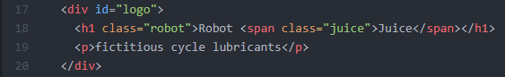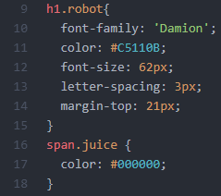This is the first part of the CSS used for the logo, this includes the ‘Robot Juice’ text. As you can see, in the ‘h1’ part of the code we have all the code used to perform the tests above. Then, using a span tag inside the ‘h1’ tag, we added the colour black for the second part of the logo as we couldn’t have the two colours within the same tag.

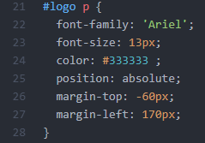This is the second section of the logo and it includes all the styling for the p tag shown in the image above. This is the only part of the webpage which is excluded from the grid as it is given an absolute position to allow me to place it directly where I needed it to go, which was under the ‘Juice’ section of the logo.

*Navigation Bar Styling*

|  |  |  |  |
| --- | --- | --- | --- |
| ***Test*** | ***Expected O/C*** | ***Actual O/C*** | ***Errors*** |
| Default browser settings for nav tag | Adding basic nav CSS, display as a block, float left and align the text to centre | Expected outcome achieved, all CSS working, block display and float left clearly applied. Text align will apply later when we position the li elements. | n/a |
| Remove default nav styling (underline, list style etc.) | All default styling for the nav elements to be removed, involves the list style and text decoration. | List style removed however text decoration still being used, underline still in place. | Text decoration not working |
| Font styling for the nav elements | Font should change to ‘sans-serif’ and font size increased to 13px as well as font changed to bold. | Expected outcome achieved, font styling updated correctly, bold text clearly visible. | n/a |
| Border for top and bottom | Light grey border to be added at the top and bottom of the elements. | Expected outcome achieved, borders applied correctly to the top and bottom. | n/a |
| Positioning of the nav bar (UL element) | Position the nav bar away from the logo to create gap between the elements, change padding to 0. | Expected outcome achieved, padding removed from UL element and margin applied between logo and nav bar element | n/a |
| Positioning of nav bar (a element) | This time I want to position the actual clickable links, also add padding between these links | Trial and error with this test trying to find the right width of each clickable link as well as the correct padding | Multiple attempts made |
| Further font changes to clickable links | Apply a colour of grey to the links as well as remove text decoration | Expected outcome achieved, font colour updated to grey and text decoration removed this time | Fixed error of text decoration not working |
| Active hover for current page loaded | Adding a hover colour of red to the active nav link for page loaded. | Expected outcome achieved, the active nav bar selection now has a red background | Grey font now hard to read with red BG |
| Changing the font style for active link | Change the colour of the text to white as well as change the font weight from bold back to normal. | Expected outcome achieved, font colour is now white and boldness has been removed making it easier to read. | n/a |
| Adding a hover to the link elements not active | Change the background colour of the nav elements not selected when hovered over to a dark grey | Expected outcome achieved, background colour updates when you hover over the unselected elements. | Used W3 schools to help with this one |
| Adding the border to the right of each element. | The border will be added to the right of each element in light grey colour. | Each element has the border to the right, including the last one which I realise now shouldn’t. Also can’t seem to get the borders to be smaller in height. | Not working as intended |
| Removing border right from the last link element | The border right property should be removed from the last list element in the nav bar | Expected outcome achieved, the last list element has had it’s right border removed. | n/a |

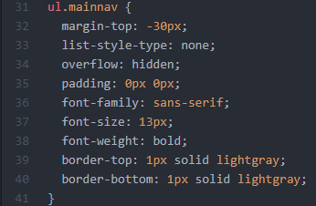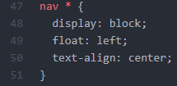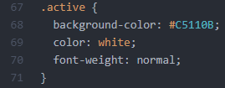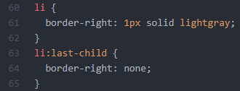

This is all the code used for the nav bar, there is a lot of different sections but all of it has been tested. Some of the tests were trial and error, such as the padding sizes and widths of the elements as I was never going to get it perfect first try. I also came across a couple errors in this section of testing, the first was the text decoration of the links not being removed, I later fixed this by placing adding the code to the actual clickable link element (a) instead of the class I made. The second error I had, which I still haven’t been able to fix is the right border on the nav bar, it is supposed to be floating without touching the top and bottom borders, but I have, as of yet, been unable to achieve this effect.

*Header Banner Styling*

|  |  |  |  |
| --- | --- | --- | --- |
| ***Test*** | ***Expected O/C*** | ***Actual O/C*** | ***Errors*** |
| Positioning header | Use margin to move the header away from the navbar, give some space in between the elements | Expected outcome achieved, banner moved down the page to provide gap in between the two elements | Trial and error with this test |
| Adding shadow effect below the image | Attempting to add a shadow effect below the image | Error, cannot seem to achieve the same effect. Tried using border and shadow with no success | Will come back too. |

*Slogan Styling*

|  |  |  |  |
| --- | --- | --- | --- |
| ***Test*** | ***Expected O/C*** | ***Actual O/C*** | ***Errors*** |
| Changing font size | Increase the font size as current one is too small. Should cover the entire row of the grid | Expected outcome achieved, font size increased to 35px as this was as close to the example given. | Trial and error with this test |
| Font colour change | Change the colour of the font to a slightly darker grey | Expected outcome achieved, font colour changed to a darker grey | n/a |
| Aligning the text to the centre of the grid | Change the alignment of the text so it is in the centre of the grid | Expected outcome achieved, text is now aligned to the centre of the page | n/a |

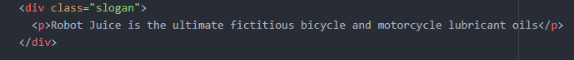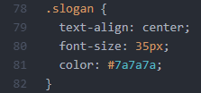

*Main Content Section 1 Styling (GRID & STYLE)*

|  |  |  |  |
| --- | --- | --- | --- |
| ***Test*** | ***Expected O/C*** | ***Actual O/C*** | ***Errors*** |
| Display images side by side with text below each image | Using a block display, move the images side by side | Error, the text is the next element inside the div and so it just moves the text next to the image instead | Not working as intended |
| Displaying them in the grid CSS | Span the div tag from column 1 to 4 to display side by side. | Error, same result as last time the text is moved to side again, as it is the next element | Second attempt failed |
| Displaying them in the grid attempt 2 | Same test as before except this time I’ve lined the elements in the HTML so the images are all together | The images are now shown side by side in the grid, but the text is all out of place, would have to create a new div for each bit of text to get same result | Looking for a better solution to the problem |
| Displaying them in the grid attempt 3 | This time I have placed the images and their relevant text together, in their own divs. Given them separate tags, item1 etc. Hoping this will align the images and text together | Expected outcome achieved, the images and text are now displayed within the grid below each other without having to separate them all. | Font styling still to be done as still slightly out of place |
| Adding a margin between each of these images | Adding a small margin between the 4 images to line them up in the centre of the grid and span the full width | Expected outcome achieved, after a few tries found the right margin which increases by 4 per image | Trial and error |
| Using the class “products” update the font for the p tag | Updating only the p tag within the products class so the font family is ‘sans-serif’ | Expected outcome achieved, p tag now changed to the font family ‘sans-serif’ | n/a |
| Using the same class, change the p tag font size | Updating only the p tag within the products class, change the font size so it is slightly bigger | Expected outcome achieved, font size lowered slightly to 12px and looks a lot better | n/a |

*Main Content Section 2 Styling (GRID & STYLE)*

|  |  |  |  |
| --- | --- | --- | --- |
| ***Test*** | ***Expected O/C*** | ***Actual O/C*** | ***Errors*** |
| Using the grid to align the elements within the “content” class | Should span roughly half the grid space, set to span 2 and start in column 1. | Expected outcome achieved, all elements within the ‘content’ class have aligned correctly with their grid positions | n/a |
| Change the h4 tag in content class to a ‘brownish’ colour | Update the h4 tags to a brown colour. | Expected outcome achieved, only the h4 tag has received an update of the colour brown | n/a |
| Update the h4 and p tag elements font family | Change the font family of the p and h4 elements to ‘sans-serif’ | Expected outcome achieved, both the h4 and p tags were updated to ‘sans-serif’ | n/a |
| Change the font size of the p tag in the content class | Update the p tags font size to around 12px | Expected outcome achieved, determined that 12 px was the best size, font updated correctly | n/a |
| Adding a margin to only the h4 and p tags | Separate them from the main header by adding a small margin from the left of the page | Expected outcome achieved, margin added to separate the content from the main header | Trial and error |